Applying a Single Cloud Mask

ECOSTRESS Tutorials

This tutorial will show you how to use code to apply a cloud mask to a single ECOSTRESS image. This code applies a cloud mask to a Land Surface Temperature (LST) image, but it can be modified for other ECOSTRESS products.

Table of Contents

What is a Cloud Mask? 1

Applying a Cloud Mask to a Single Image 1

# What is a Cloud Mask?

A cloud mask is an image used to help determine if there is cloud presence in remotely sensed imagery. The mask is binary, meaning it either indicates the presence of a cloud or it does not. If it does indicate the presence of a cloud, that pixel can be removed from the remotely sensed image to improve the accuracy of the overall image.

**Tip**: Make sure you have **Cloud Mask files** downloaded in addition to your ECOSTRESS product files. If you do not know how to download these files, see the **Downloading from AppEEARS** tutorial.

## Applying a Cloud Mask to a Single Image

1. Download the **Single_Cloud_Mask** code from <https://github.com/ECOSTRESS-Tutorials/ECOSTRESS-Single-Cloud-Mask>.
2. Open your **finder**.Create a **project folder** to store all the files for this project by **right clicking** and selecting **New Folder**. Name your new folder so that you know it is the main project folder.

1. **Move** the **downloaded code** file into the project folder.

1. **Move** thefolder with your **downloaded ECOSTRESS data** into the project folder.

1. In the project folder, create a new **sub folder** to store the completed cloud masked file. To do this, go inside the project folder, **right click**, and select **New Folder**. Then name the folder so that you know it is for the **outputs**.

1. Next, open **Visual Studio Code** and use **File > Open Folder…** to get connected to the main project folder that contains the downloaded ECOSTRESS files, the Single_Cloud_Mask code, and the output subfolder.

|  |  |
| --- | --- |
|  |  |

1. In the **EXPLORER** tab, find the **Single_Cloud_Mask** code and click on it to open it.

**Tip**: If you want to know more about what each line of the code does, read the **comments** in the code. Comments in the code are identified by **#**. These comments do not actually change how the code runs, but they can be helpful to put notes on how the code works for yourself or other users. This can also be helpful if you want to customize the code because it will guide you to which parts you may want to change!

**Examples** of comments (**green text following the #):**

1. Find the section of the code titled **Load and View the Surface Temperature Image**. Find the variable called **ST_filepath**. Change the text that says **"Replace_this_text_with_file_path"** to the path to the ECOSTRESS LST image that you want to cloud mask.

* 1. To **copy the file path**, use the **EXPLORER** panel on the left side of Visual Studio Code to find the file you are interested in. Once you have found it, **right click** on it and select **Copy Path**. Now you can paste the path into your code. Make sure it is still **wrapped in quotes** and has **r** outside the first quote.

**Example:**



1. Now, find the section of the code titled **Load and View the Cloud Mask**. Find the variable called **cloud_filepath**. Change the text that says **"Replace_this_text_with_file_path"** to the whole file path of the corresponding **Cloud Mask** image for your LST image. To make sure it is the corresponding Cloud Mask image, make sure that the **date codes** of both the LST and Cloud Mask images **match**. The date code is the string of numbers listed after **doy** in the file names. Make sure it is still **wrapped in quotes** and has **r** outside the first quote.

**Example:**



1. Finally, scroll down to the section titled **Save the Masked Image**. Find the variable titled **output_folder_path**. Change the text that says **"Replace_this_text_with_folder_path"** to the name of the folder where you want the output file to be stored. Make sure it is still **wrapped in quotes** and has **r** outside the first quote.

**Example:**



1. Now the code should be set up to be run with your desired image. Scroll back to the top to the section titled **Import the Libraries we Need to Apply the Cloud Mask**. This is the first block of code we want to run. Click into the box with the library importing code and press **Shift+Return** to run it.

1. At the top of the window, a pop up will appear prompting you to **select a kernel** to run your code with. Click on **Python Environments …**

1. Select the **ECOSTRESS** environment that you created, or another one if you have a different one you want to use.

**Tip**: If you do not have an ECOSTRESS environment set up, follow the **Creating an Environment** tutorial to make one.

1. Let the code run for a few seconds. You will see the **seconds counting up** in the bottom left of the cell. You will know it is done when a **green check mark** appears.

1. Continue this process of running each block of code, in order from top to bottom, by clicking into the module with the code and pressing **Shift+Return**.
   1. The **Load and View the Surface Temperature Image** section will generate a map showing the surface temperature of the LST file you uploaded. **Example:**

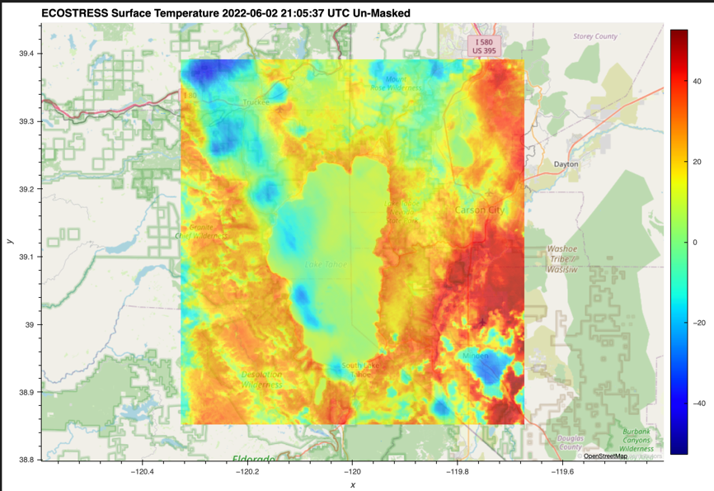

* 1. The **Load and View the Cloud Mask** section will map the binary image of the cloud mask you uploaded. The blue shows areas that are good to be kept, and the **red** shows areas that **should be removed** due to possible cloud cover. **Example:**

* 1. The **Apply the Cloud Mask to the Surface Temperature Image** section will generate a map of surface temperature, but with areas where clouds are indicated removed. This is the image that will be saved to your output folder when you run the final **Save the Masked Image** section of the code. **Example:**

* 1. Finally, the **Save the Masked Image** section will save the masked image as a .tif file into the folder that you specified as your outputs folder. You can check to make sure that a file is present in that folder so that you know your code ran correctly.

You have now cloud masked an individual ECOSTRESS image!